Table of contents

* Version history ……………………………………………………………………………………. 2
* Game description ……………………………………………………………………………….. 2
* Controls ……………………………………………………………………………………………… 3
* Game screen information ………………………………………………………………….. 3
* Space ship …………………………………………………………………………………………. 5
* Enemy ship ………………..……………………………………………………………………… 6
* Scoring ……………………………………………………………………………………………….. 6
* Art and multimedia Index ………………………………………………………………….. 6

**2D Space Shooter Version 1.0**

**Your mission:**

The galaxy is terrorised by enemy ships that know only one thing; destruction. Your job is to destroy the enemy ships before they destroy you. You are the only thing standing between the enemy ships and the galaxy, may the force be with you. Watch out for enemy ship gun fire and defend your self with your laser beams. Try not to run into enemy ships or you will be destroyed. keep your eyes open and weapons hot!

Controls

W ---------------- Up

A ----------------- Left

S ----------------- Down

D ---------------- Right

Space bar ----- Fire laser beam

**Game Interface**

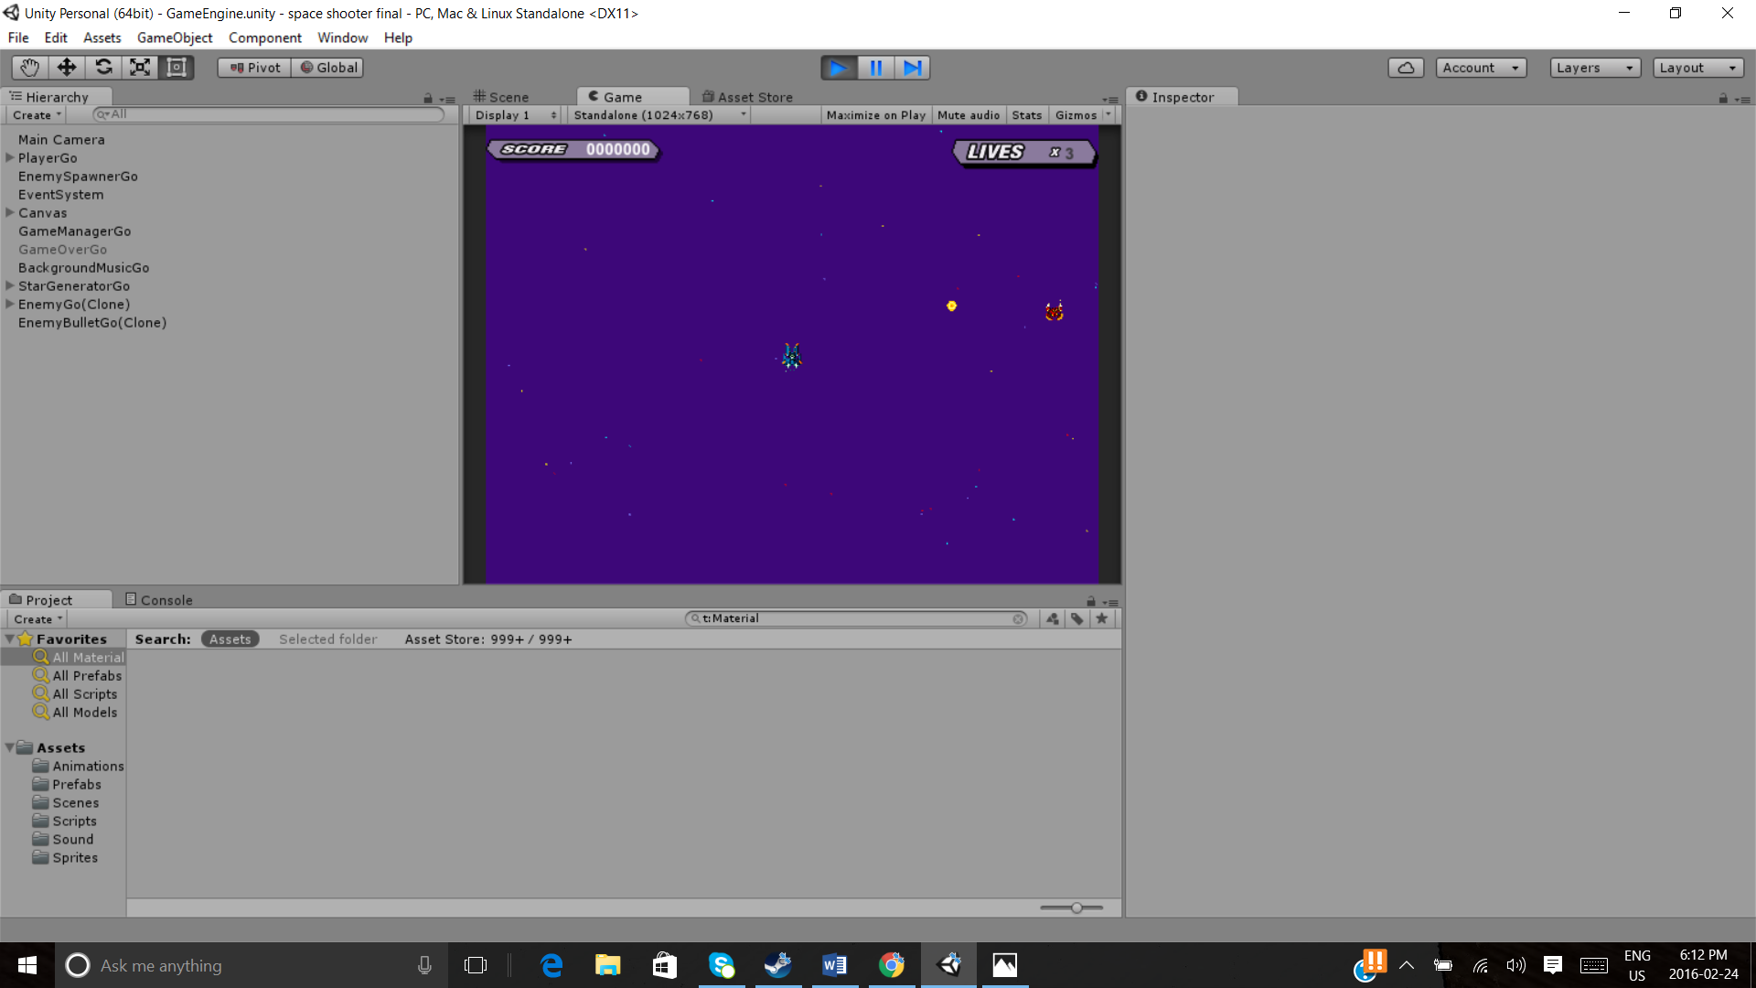 Score tab lives

Enemy ship

Spaceship

**Game Start Screen**

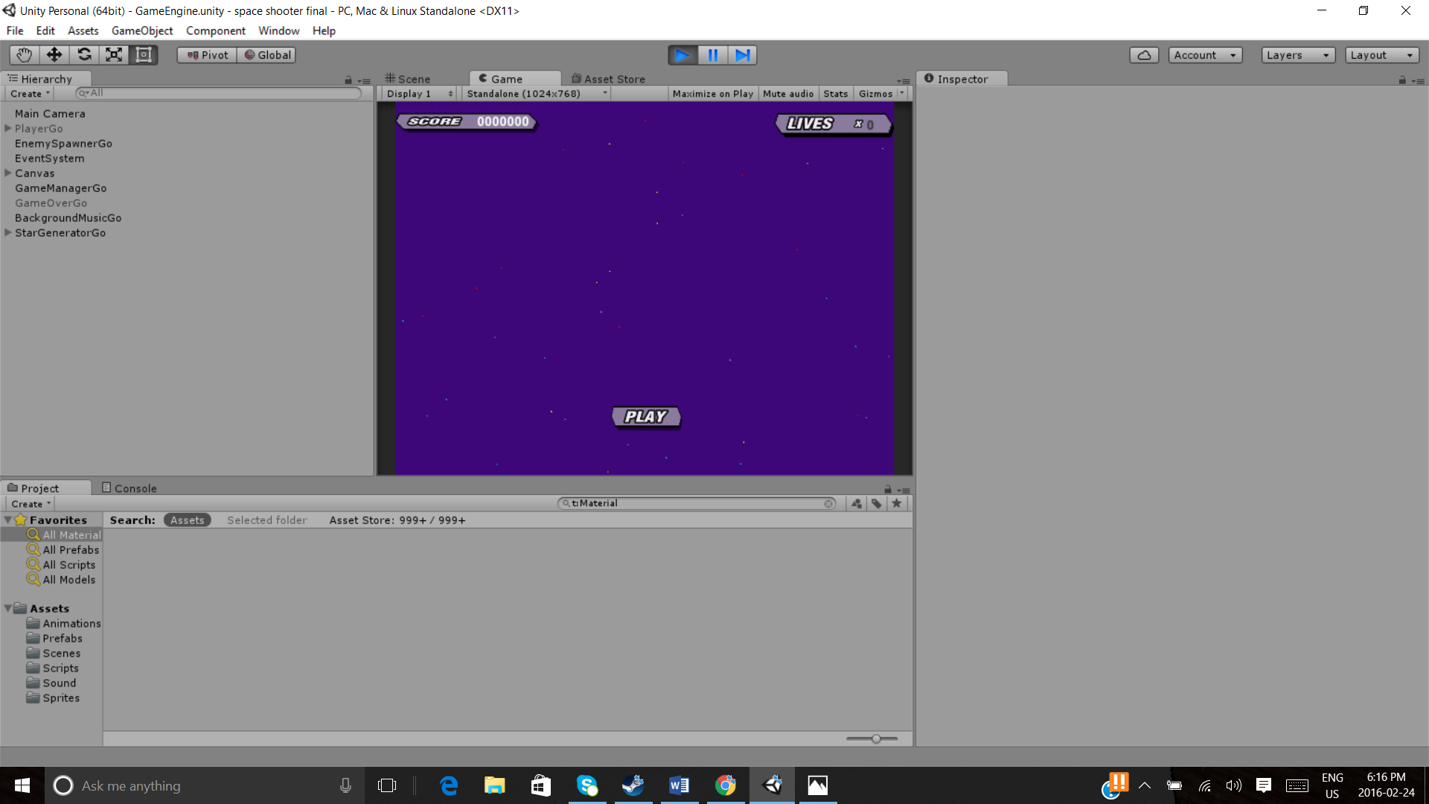

**Game play Screen**

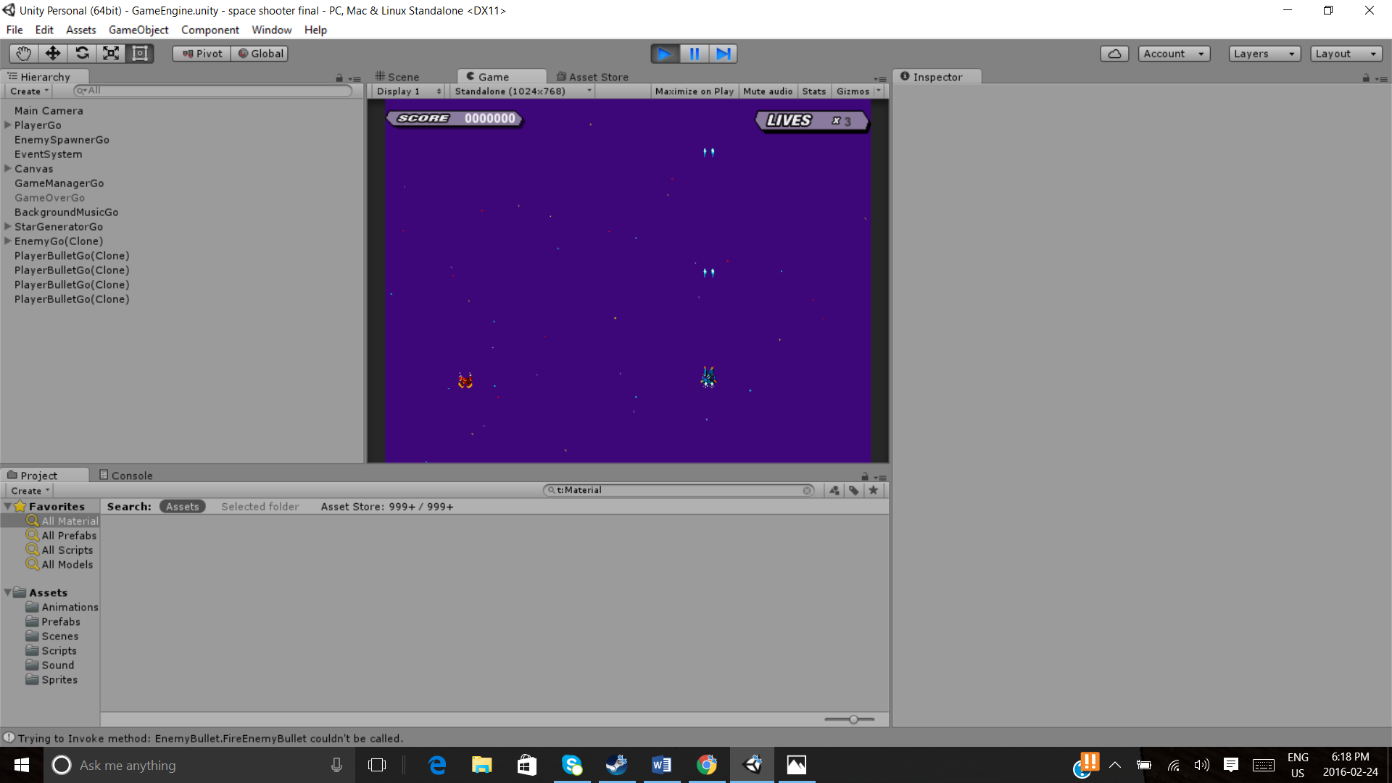

**Game over screen**

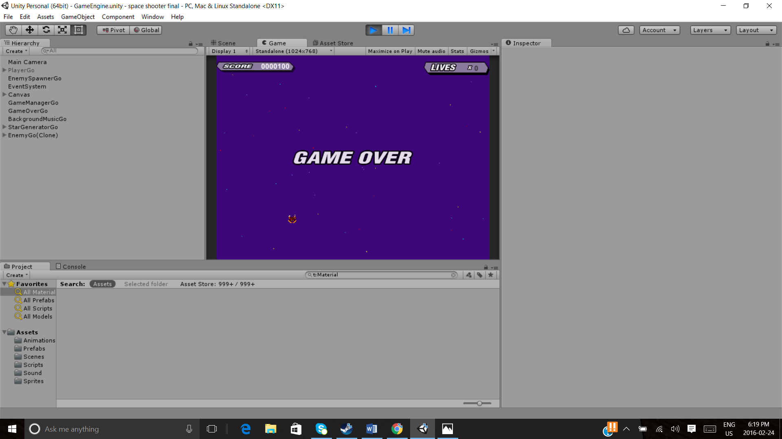

**Your Space ship**

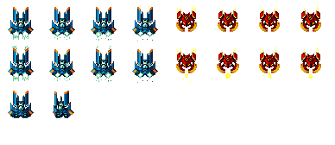

**Your Enemy**



**Scoring**

For each enemy ship you destroy you get 100 points.

**Sound index**

BackgroundMusic.wav

Boom.wav

Shoot.wav